Strings Repository

Used for creation and management of all interface text, including elements such as ADF messages and embedded help.
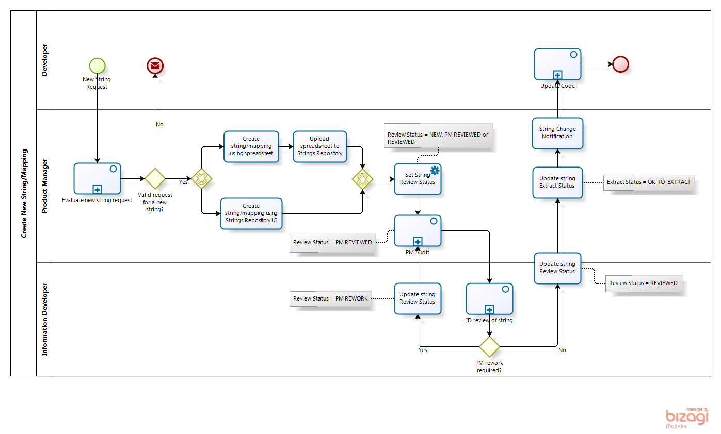
Strings follow specific writing standards and subjected to GSCC standards (mandatory from R13) for validation.

Reviewing Strings in the String Repository

Product teams send strings to Info Dev for review. When the strings are finalized, they are created in the string repository (SR). Once the strings are created in the SR they are approved by Info Dev.

Strings in "PM Reviewed" status in the strings repository (SR) are ready for InfoDev review. Follow these steps below to locate, review, and update the strings that are ready for your review.
- Go to the Update Strings page in the SR:
https://rms.us.oracle.com/tscaweb/strings/updateStrings.jsp
- Select a product family, such as SCM, and then select your product shortcode. Select the review status PM REVIEWED. Click Search.
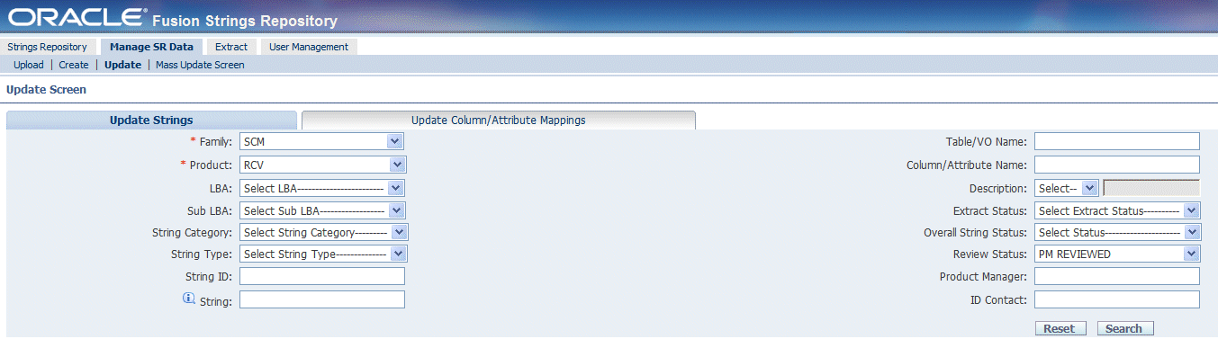
- In the String Category region, select Column/Attribute (for Model Layer strings) or General Page UI (for View Layer strings).
- In the String Type region, leave as Select String Type or select a string type to focus your attention on specific types of edits (recommended).
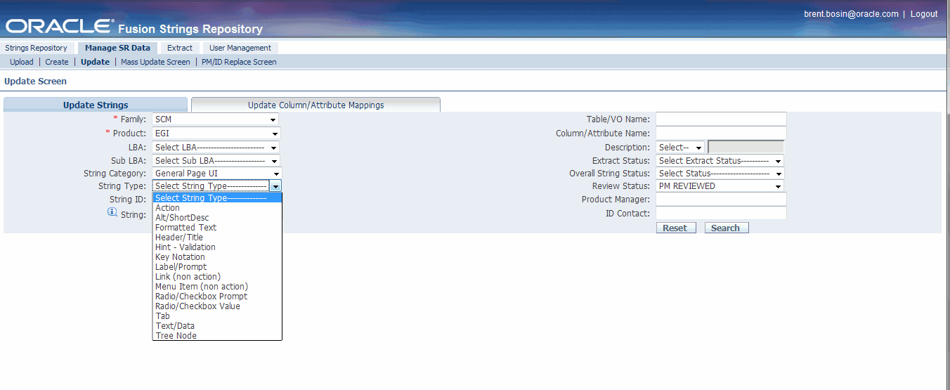
- In the Search Results region, click the Show link to show details for any string, or click Expand All to show details for all strings.
- For each string, read the text in the String, Fully Qualified String, Fully Qualified Description, Comment, and Review Comments fields (some of these fields may be blank).
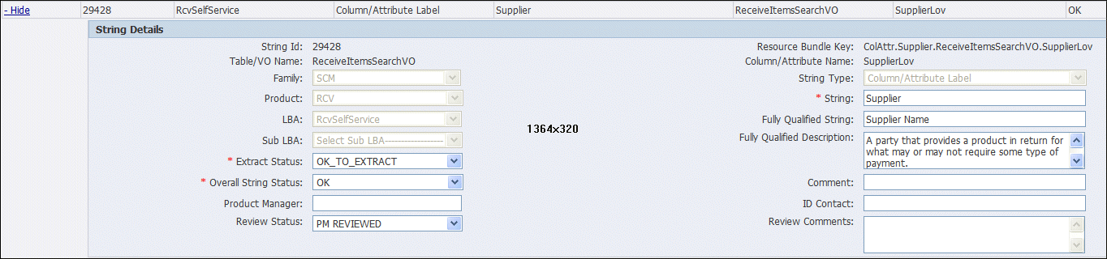
- Review and update the string, fully qualified string, and fully qualified description according to these guidelines:
Strings and Fully Qualified Strings
- If you did not previously review the string (in an offline string spreadsheet), then review the string using the ID String Repository Checklist.
- If you need to make changes to the string, then enter those suggested changes into the Review Comments field; do not update the string directly. Use the following format: <date> <global user ID>: <suggested change>. For example:
27-Oct-2009 cbauer: Change fully qualified string from Ship-To Location to Ship-to Location.
Fully Qualified Descriptions
- Ensure the descriptions describe the fully qualified string where one exists. In some cases, a description matches the string, but not the fully qualified string. (If no fully qualified string exists, then ensure the description describes the string.)
- Review the description for spelling and grammar errors. If you’d like to run an automated spell check in a spreadsheet, then see the Instructions for Downloading Strings section.
- Ensure the description is readable and usable; that is, can readers makes sense of it and understand what it means? You are not required to wordsmith, so if a description is usable but could be written better, leave it. (The string descriptions are not customer facing.)
- If you need to make changes to the description that the PM owner does not need to review – such as spelling, grammar, or capitalization corrections, or fixes to the description that do not change the meaning – then make those changes directly to the string description.
- If you need to make changes that the PM owner does need to review, then enter those suggested changes into the Review Comments field; do not update the string description directly. Use the following format: <date> <global user ID>: <suggested change>.
- Update the review status of the string as follows:
- If you have no suggested edits to the string, fully qualified string, and fully qualified description, then set the status to REVIEWED.
- If you have made edits directly to the fully qualified description, then set the status to REVIEWED.
- If you have entered suggested changes into the Review Comments field, then set the status to PM REWORK.
- Enter your first and last name into the ID Contact field. (This is recommended, but not required.)
- Click Update Strings.
- Notify the PM owner of the strings when you have completed your review. If you set any strings to PM REWORK status, let the PM know.

Instructions for Downloading Strings
If you’d like to download your strings into a spreadsheet, do the following:
- On the Update Strings page, click the Strings Repository tab.
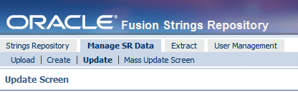
- On the SR home page, select product family SCM, and then select your product shortcode. Selected the review status PM REVIEWED. Click GO.
- At the bottom of the Strings region, click the All Pages button if more than 25 records exist.

- Click the Download link and select the download format

